**Migratory situation in July – Arrivals in Europe up slightly from previous month**

2019-08-13

In July, the number of detections of illegal border crossings on Europe’s main migratory routes rose 4% from the previous month to around 10 500. Overall, the total for the first seven months of 2019 was 30% lower than a year ago at around 54 300.

**Eastern Mediterranean**The Eastern Mediterranean remained the busiest migratory route into Europe with nearly 5 800 detections in July 2019*.

In the first seven months of this year, the total number of detections in this region was down 6% from a year ago to almost 28 200. Despite the overall decrease, the number of arrivals on the Greek islands in the Aegean increased by a quarter in comparison with the same period of last year.

Most of the migrants detected on this route were nationals of Afghanistan.

**Western Mediterranean**The number of irregular migrants taking the Western Mediterranean Sea route in July rose 22% from the previous month to almost 2 900.

The total for the January-July period stood at around 13 000, 41% less than in the same period of last year.

Migrants from sub-Saharan Africa accounted for the largest number of detected migrants on this route in the first seven months of 2019.

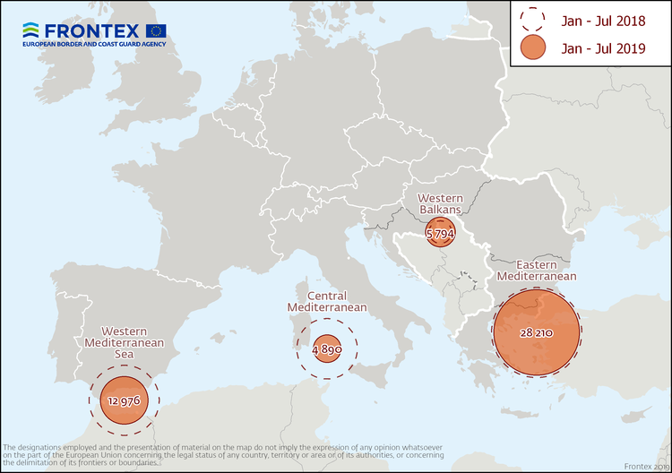

**Central Mediterranean**The number of migrants passing through the Central Mediterranean in July stood at around 1 100.

The total for the first seven months of the year reached nearly 4 900, slightly more than a quarter of the total from the same period of last year.

Nationals of Tunisia, Sudan and Pakistan were the most represented nationalities on this route in the January-July period.

**Western Balkans**There were 460 detections of illegal border crossings recorded on this route in July. The total for the first seven months reached nearly 5 800, double the figure from a year ago.

Nationals of Afghanistan and Iran accounted for the largest share of migrants detected on this route.

*July 2019 data does not include the number of detections in Cyprus.

*Note: The data presented in this statement refer to the number of detections of irregular border-crossing at the external borders of the European Union. The same person may attempt to cross the border several times in different locations at the external border.*